Contents

**Introduction:** 2

**Implementation** 3

Benefits of having a photography website 3

What is HTML? 3

What is CSS? 3

Folder structure 4

Navbar 5

Hero Header 7

About Section 9

Portfolio Section 11

Services Section 13

Content Section 15

Footer 17

Final Touches 18

**Conclusion :** 19

**Reference :** 20

Figure 1 : 1 Screenshot create the folder structure in GitHub 6

Figure 2 : 2 Screenshot Import Required Module in HTML 6

Figure 3 : 3 Screenshot Import Required Module in CSS 6

Figure 4 : 4 Screenshot HTML Code in Navbar 7

Figure 5 : Navbar output without CSS 7

Figure 6 : 5 Screenshot CSS code in Navbar 8

Figure 7 : Navbar output HTML and CSS 8

Figure 8 : HTML code in Hero section 9

Figure 9 : Hero section Output without CSS 9

Figure 10 : CSS Code in Hero section 10

Figure 11 : Hero Section output With HTML and CSS 10

Figure 12 : HTML Code in About Section 11

Figure 13 : About Section Output Without CSS 11

Figure 14 : CSS Code in About section 12

Figure 15 : About Section Output with CSS and HTML 12

Figure 16 : HTML Code in Portfolio section 13

Figure 17 : Portfolio section Output without CSS 13

Figure 18 : CSS Code in Portfolio Section 14

Figure 19 : Portfolio Section with HTML and CSS 14

Figure 20 : HTML Code in Services Section 15

Figure 21 : Services Section Output without CSS 15

Figure 22 : CSS Code in Services section 16

Figure 23 : Services section Output with HTML and CSS 16

Figure 24 : HTML Code in Content section 17

Figure 25 : Content Section Output without CSS 17

Figure 26 : CSS in Content Section 18

Figure 27 : Content Section Output with HTML and CSS 18

Figure 28 : HTML Code in Footer 19

Figure 29 : Footer Output without CSS 19

Figure 30 : Footer Code in CSS 20

Figure 31 : Footer Output with HTML and CSS 20

# **Introduction:**

A photography is a scenario that I was given to do in this assignment. The task was to build a website wherein show my best photo in website.

Designing a photography is a great way to practice your HTML and CSS skill. Start by creating a basic HTML template and then style it with CSS. I can include picture and other types of content in my photography.

# **Implementation**

## Benefits of having a photography website

Having a photography website has several benefits, including:

* 1. It provides a platform to showcase your relevant skills and experience.
  2. It shows Photography
  3. I am easily searchable on search engines like google

## What is HTML?

HTML stands for Hyper Text markup Language. It is used to designs web pages using a markup language. HTML is the combination of Hypertext and Markup language. A markup language is used to define the text document within tag which defines the structure of web pages.

I can use an additional element built-integrated **section, <a> hyperlink, header, footer, and navigation**.

## What is CSS?

Cascading Style Sheet, fondly referred to as CSS, is a simply designed language intended to simplify the process of making web page Presentable. CSS allows I to do this independent of the HTML that makes up each web page. This is I am using the HTML page to import the style sheet in **head section**.

I am used the CSS in **Inline** and **External**.

## 

## Folder structure

I will now start working on creating the Photography website.

First, let’s create the folder structure. I can get the project start files on **GitHub**.

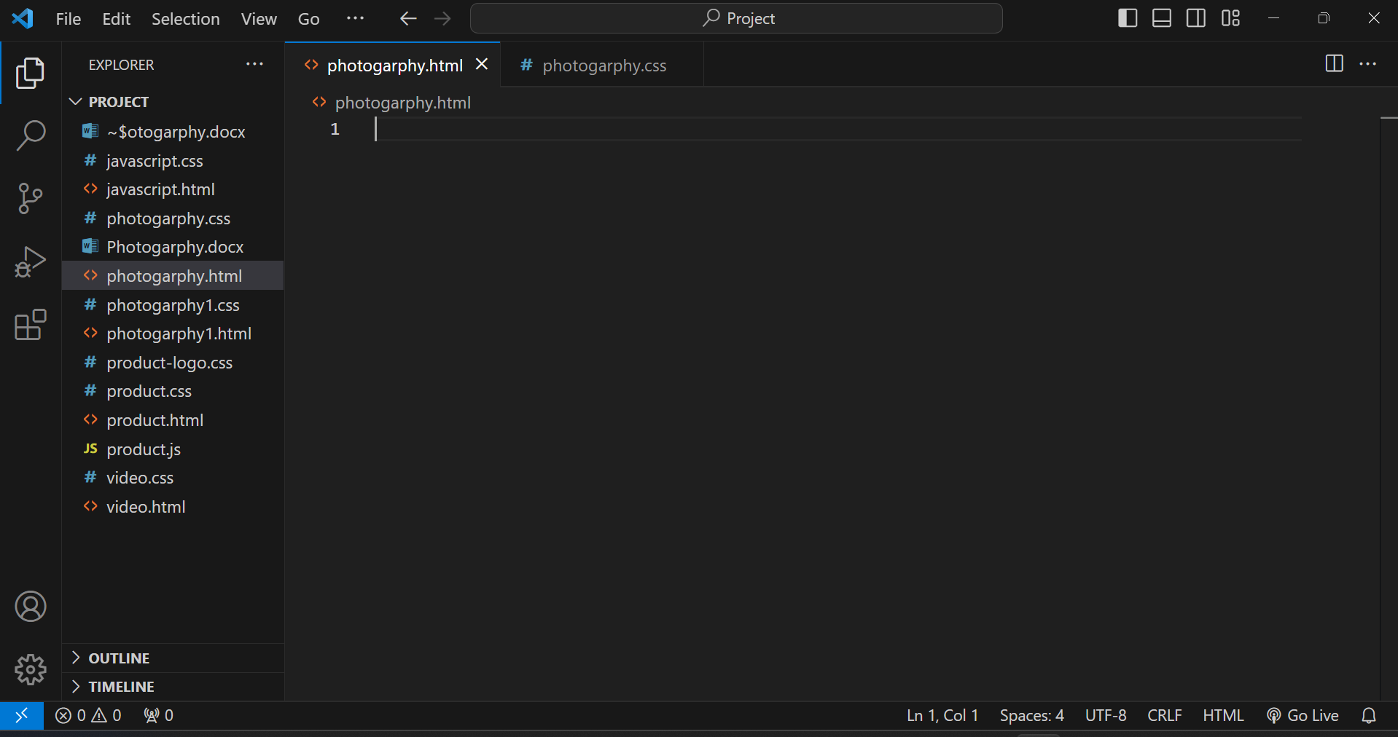

Figure 1 : 1 Screenshot create the folder structure in GitHub

Import all the required module

HTML

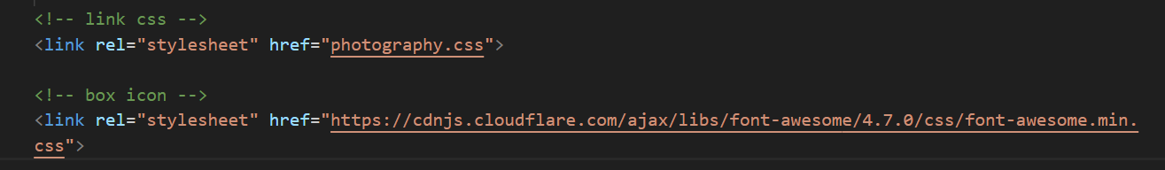

Figure 2 : 2 Screenshot Import Required Module in HTML

CSS

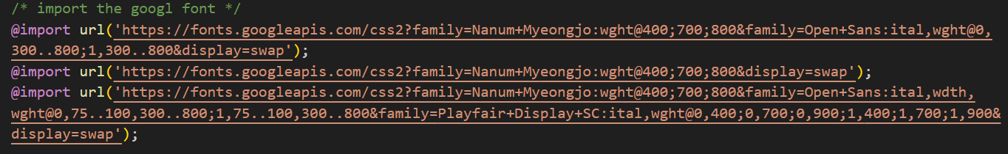

Figure 3 : 3 Screenshot Import Required Module in CSS

## Navbar

Now, let’s work on adding a navigation menu in project. It will use HTML’s **introduction** Class in nav element to keep the navbar at the top of the page. Let’s I am used for **unorder** **list**. This section I used the **nav, a, ul and li** tags and **icons**.

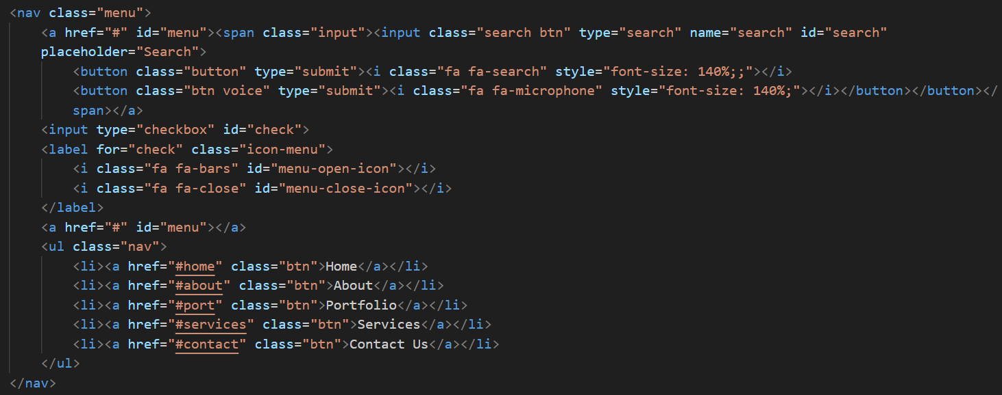

Figure 4 : 4 Screenshot HTML Code in Navbar

This is the side look so for without CSS navbar:

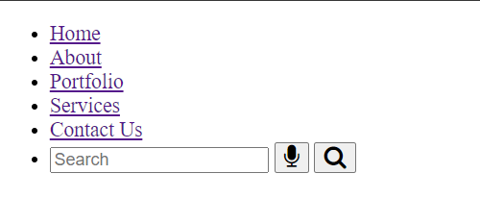

Figure 5 : Navbar output without CSS

Also, let’s add the CSS the above code into style.CSS file:

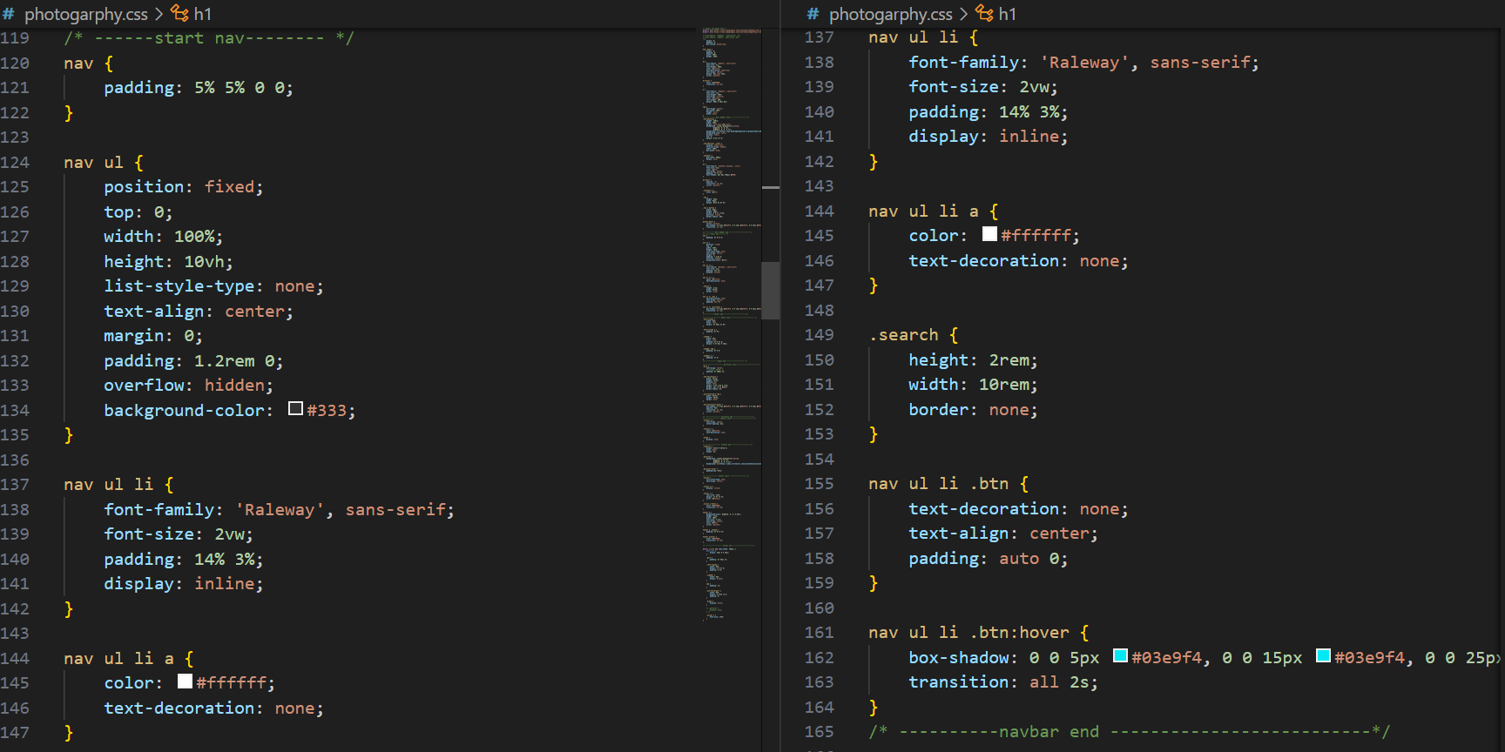

Figure 6 : 5 Screenshot CSS code in Navbar

This is the side look so for with CSS navbar:

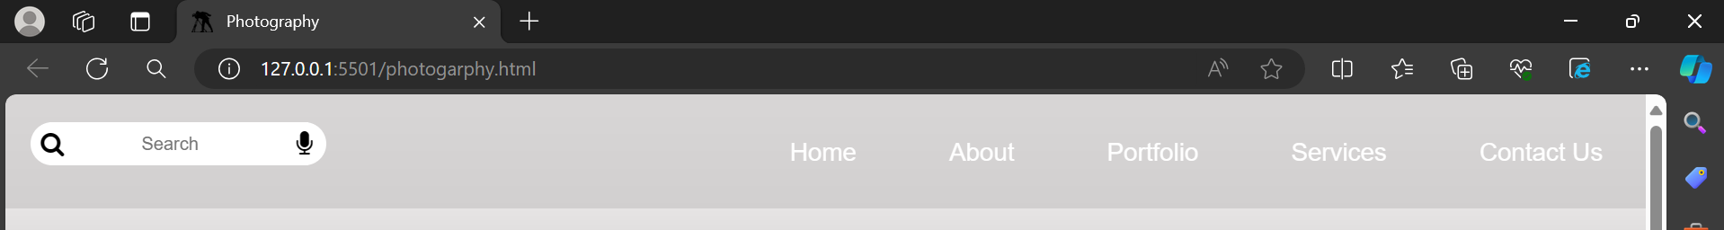

Figure 7 : Navbar output HTML and CSS

The navbar has the following features:

* It has a six links: home, about, services, portfolio, contact and footer
* It has a background. I will add a dark background on page.

## Hero Header

Now, I will be adding a hero image with some text in the center. A hero image is a web design term which refers to a high-quality full width image that displays the name or individual’s goals, a representative image, photo or other eye-catching elements. It helps attract user to site. Let’s I am using this section **div, h1, p, a, and button** tags and **icon**. This section I am using the **target** attribute specifies where to open the link document.

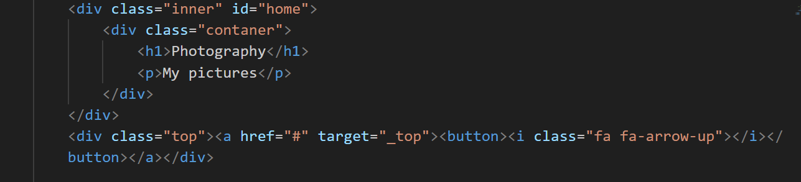

Figure 8 : HTML code in Hero section

This is showing the site looks so for without CSS the navbar and the hero section:

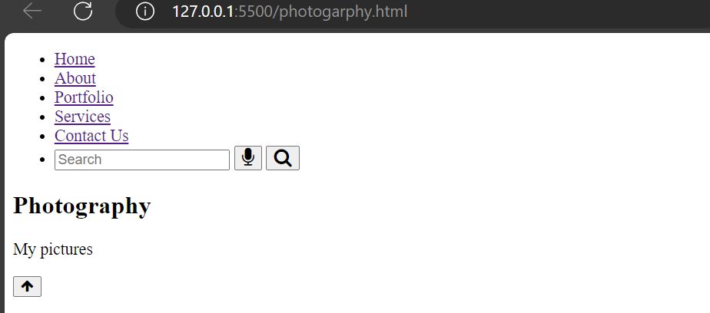

Figure 9 : Hero section Output without CSS

Also, let’s add the CSS the above code int style.CSS file:

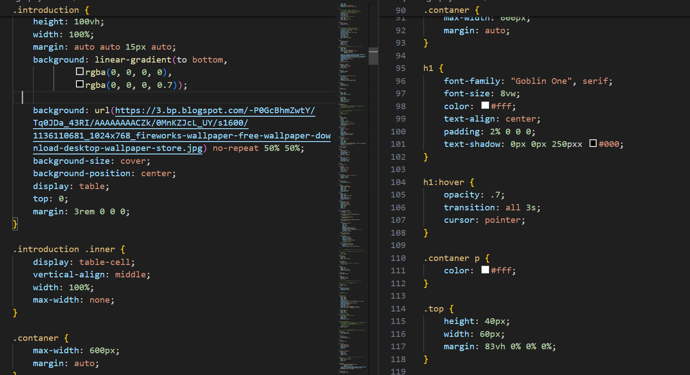

Figure 10 : CSS Code in Hero section

Here we can see that the section has an id named **background** which is responsible for display the background hero with full width. It also displays some text center above the background image with the help of the above CSS.

This is showing the site looks so for with CSS the navbar and the hero section:

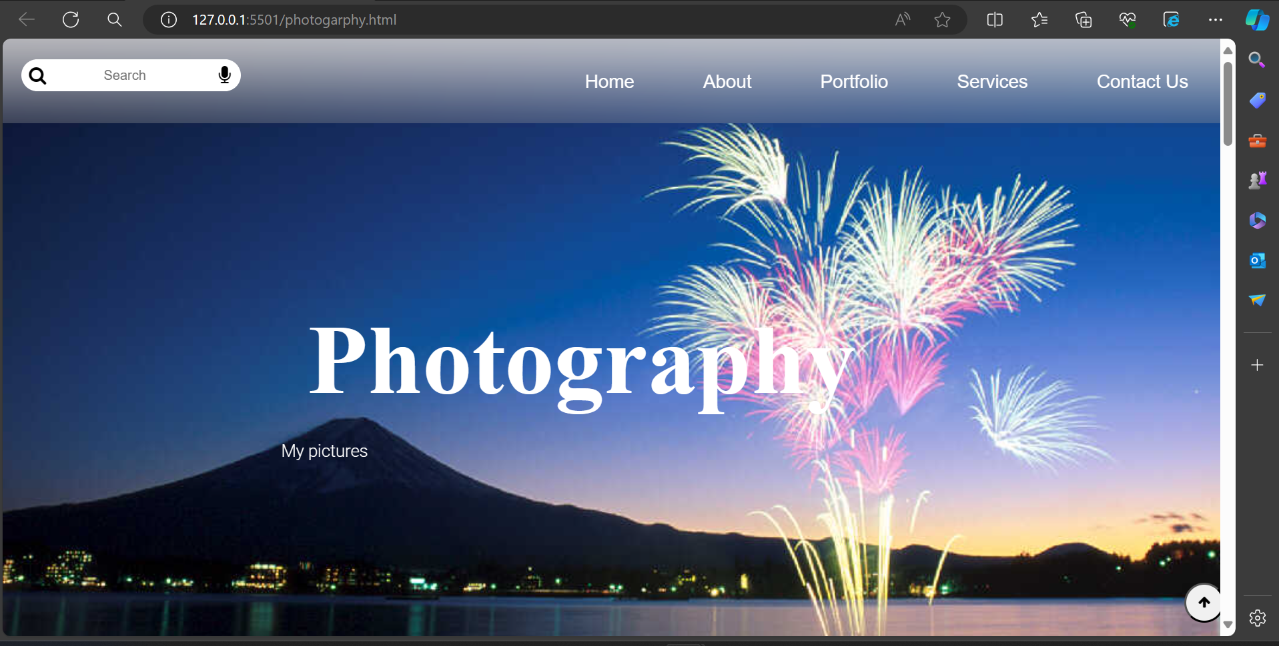

Figure 11 : Hero Section output With HTML and CSS

## About Section

The About page contains important information about I and web background. Visitor to my portfolio I’m provide this page.

I will be adding an image to the left side of the row and on the right side I will add our quick introduction in this section. Let’s demonstrate it using the code below. I used this section **h2, p** and **img** tags.

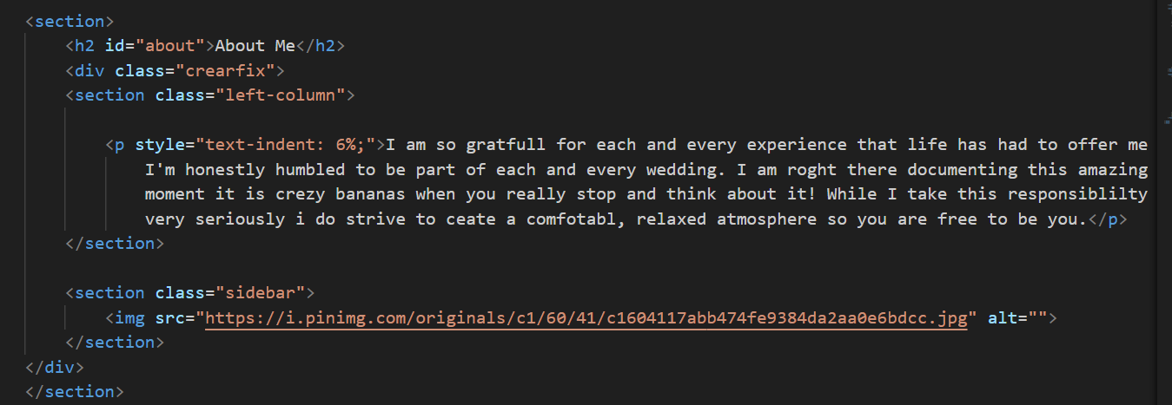

Figure 12 : HTML Code in About Section

This is showing the site looks so for without CSS the About section:

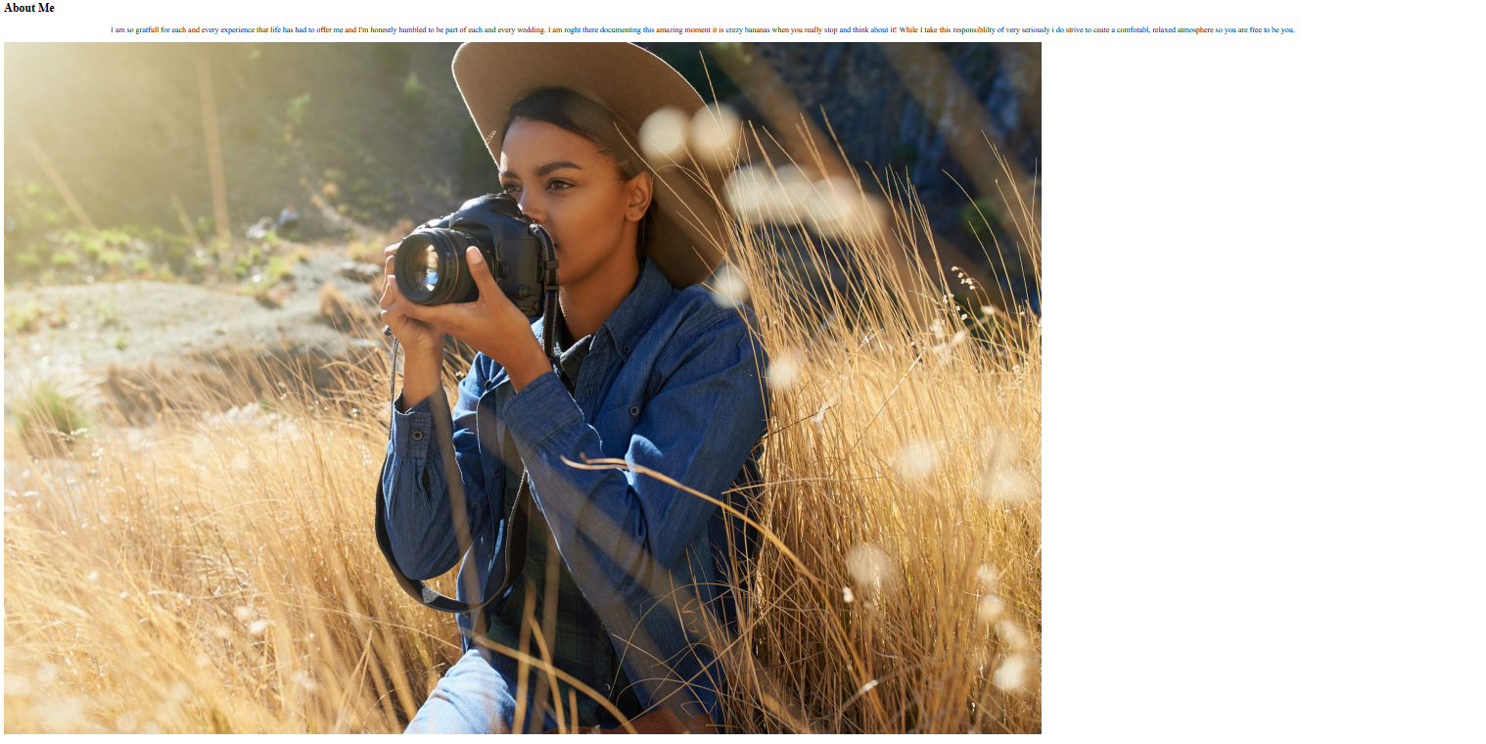

Figure 13 : About Section Output Without CSS

Let’s add some CSS for the left side image:

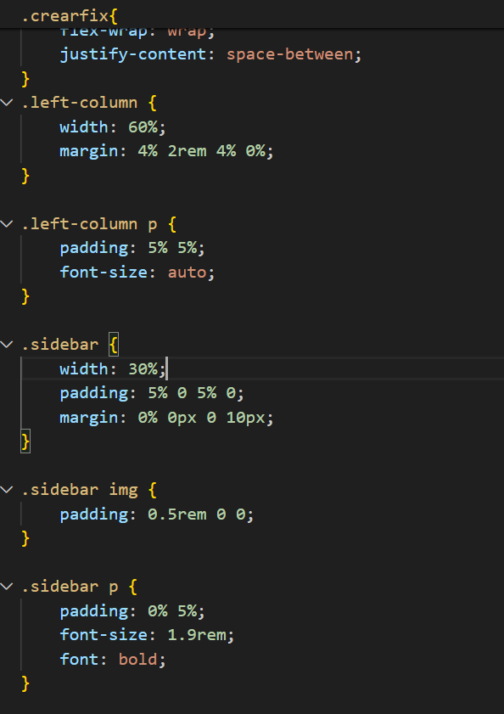

Figure 14 : CSS Code in About section

This will create an about section. I can modify the content on My cases. I have added class name **left-column** with container class which will set the margin 0% 0px 0 10px and padding 2% 5%. The row has two columns. One has the **sidebar** class for display the image which occupy the left column.

The next column with assigned a class of **left-column**  which will occupy the right column . For medium and small screen they will overlap.

This is showing the site looks so for with CSS the About section:

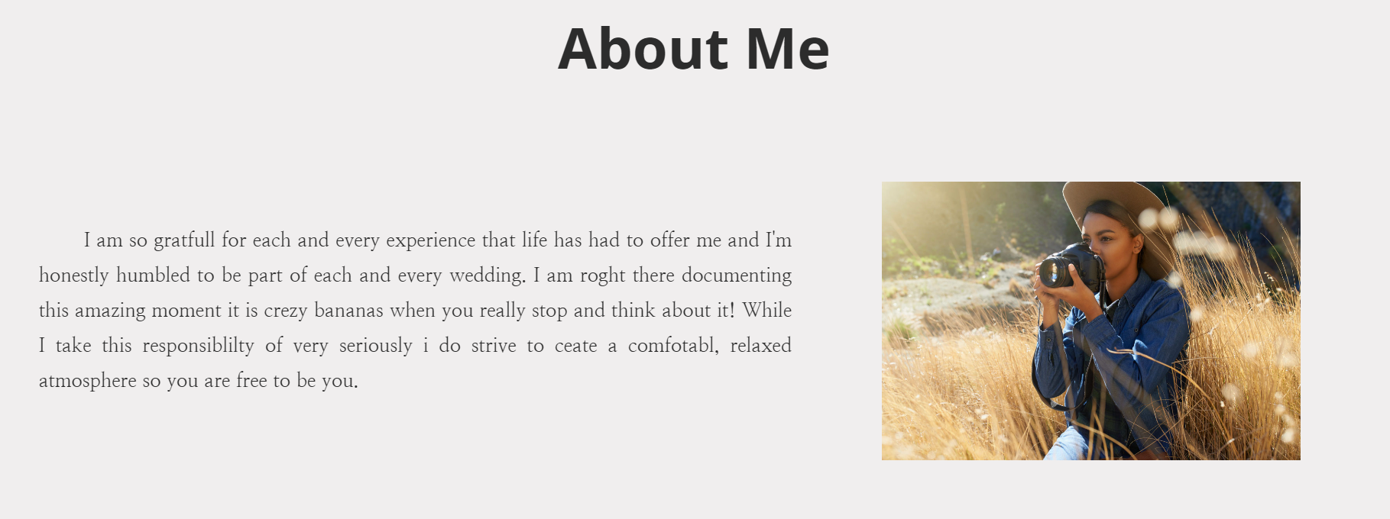

Figure 15 : About Section Output with CSS and HTML

## Portfolio Section

This section includes My best work. People can see what My capable of doing, and showcasing strong past work will definitely attract more potential clients or recruiters.

I will use CSS cards to display the portfolio projects. There will be 2 rows and each row will have 3 columns of cards. I can use **h2, a, iframe, and img** tags and **target** attribute. This section is targeting attribute specifies to open the link document in new tap.

This will be the code for portfolio section:

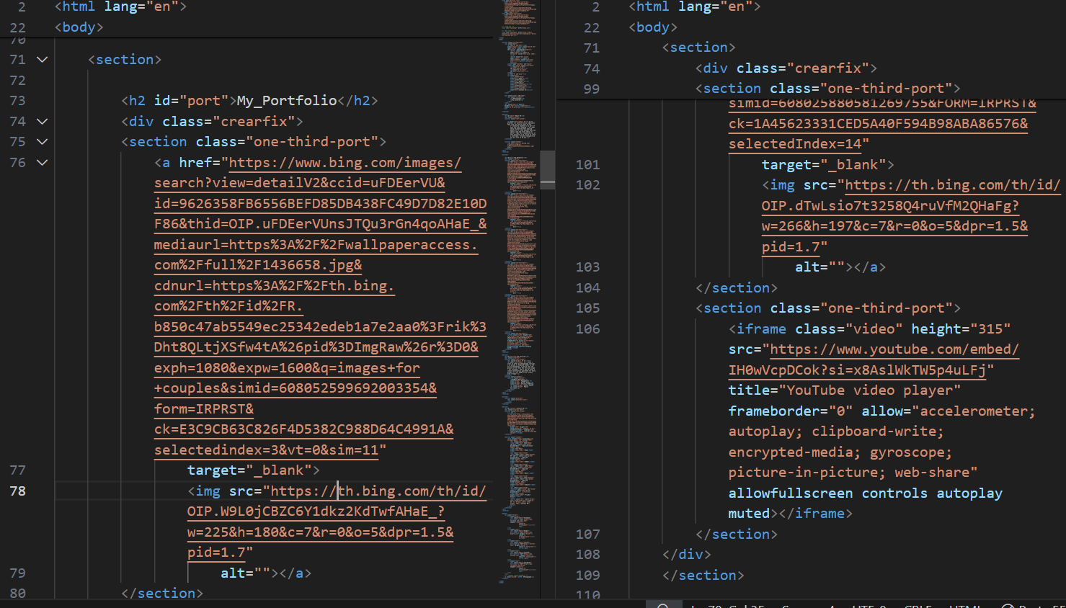

Figure 16 : HTML Code in Portfolio section

This is showing the site looks so for without CSS the portfolio section:

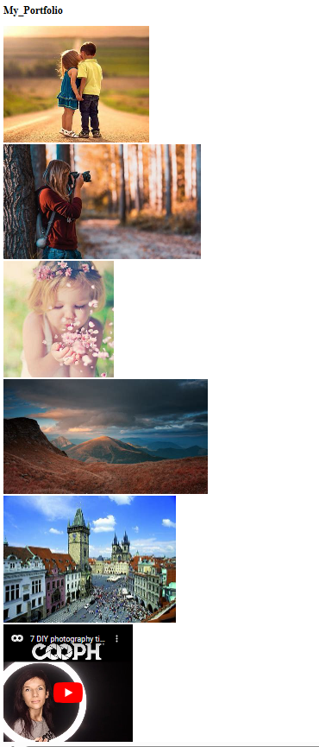

Figure 17 : Portfolio section Output without CSS

Each an image and video, and link to website for images. All cards are displayed in a for same screen.

The images and video are now display in the left side; I am used the **hover**  effect in the images.

Let’s some add the CSS code:

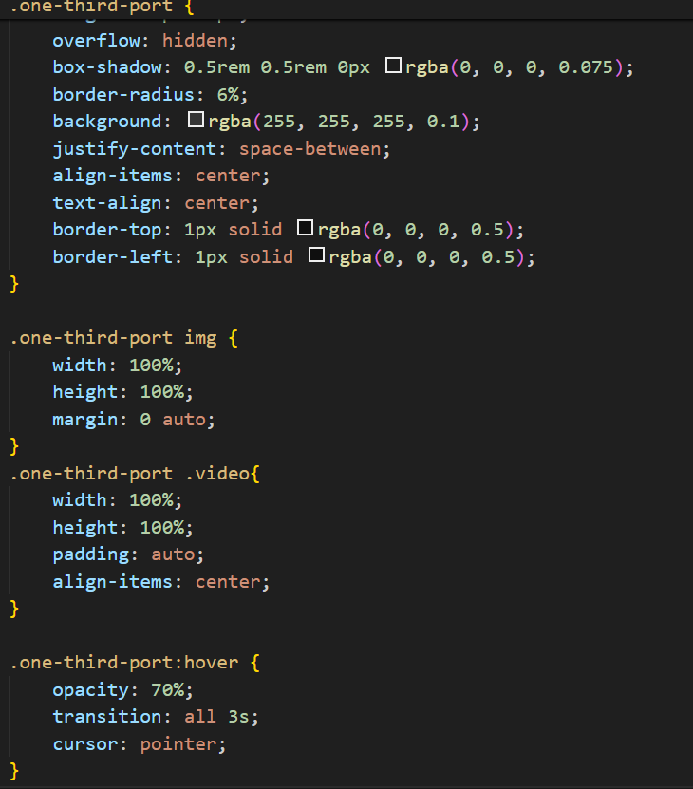

Figure 18 : CSS Code in Portfolio Section

This is showing the site looks so for with CSS the Portfolio section:

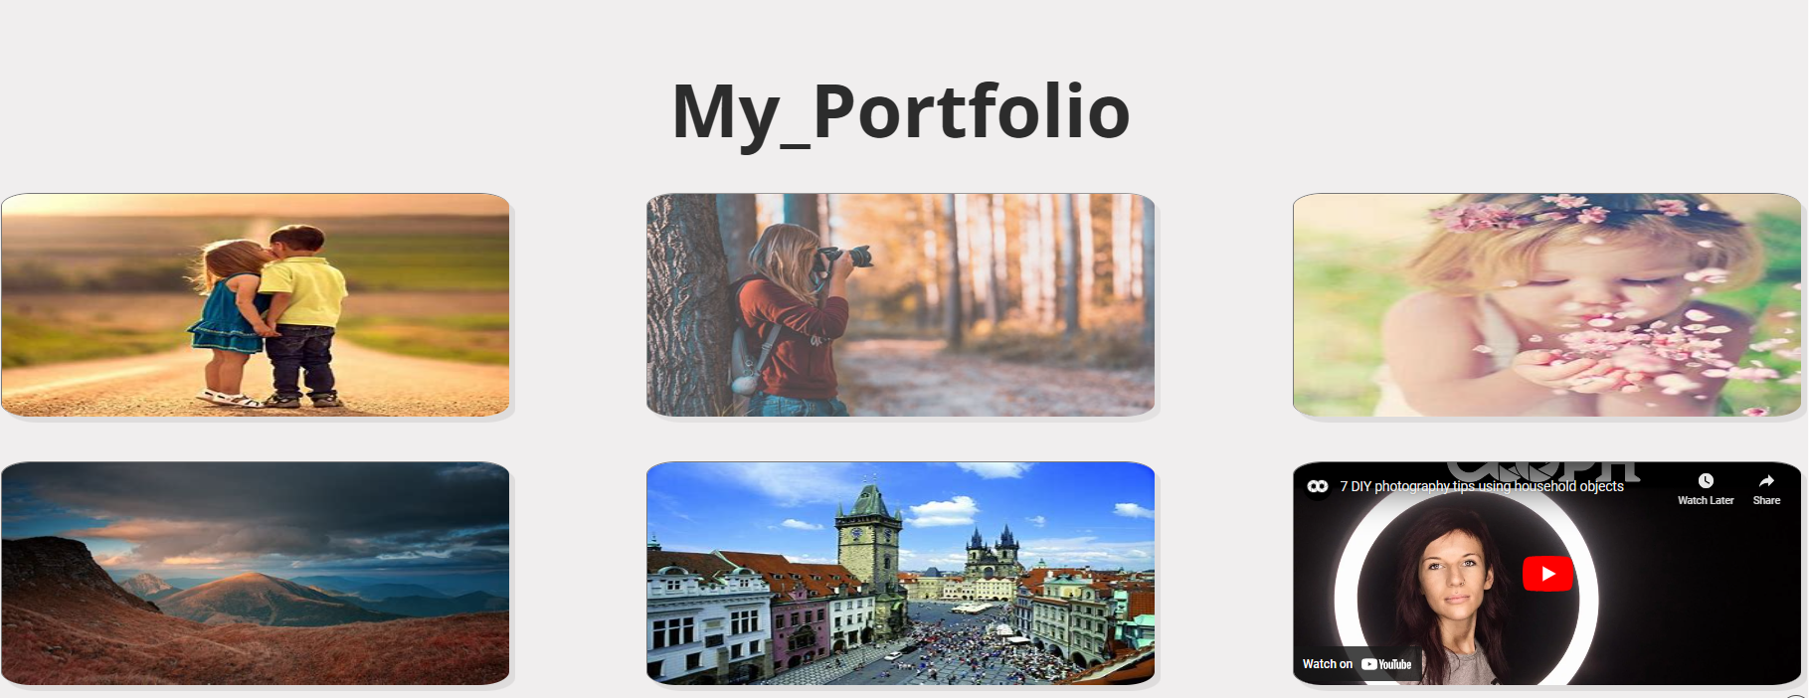

Figure 19 : Portfolio Section with HTML and CSS

## Services Section

This section helps convert website visitors into potential clients. This is where I explain what specific services. This section I used the **h2, p** and **br** tags. I used in line CSS in p tag.

Let’s add the code for this section and describe it below.

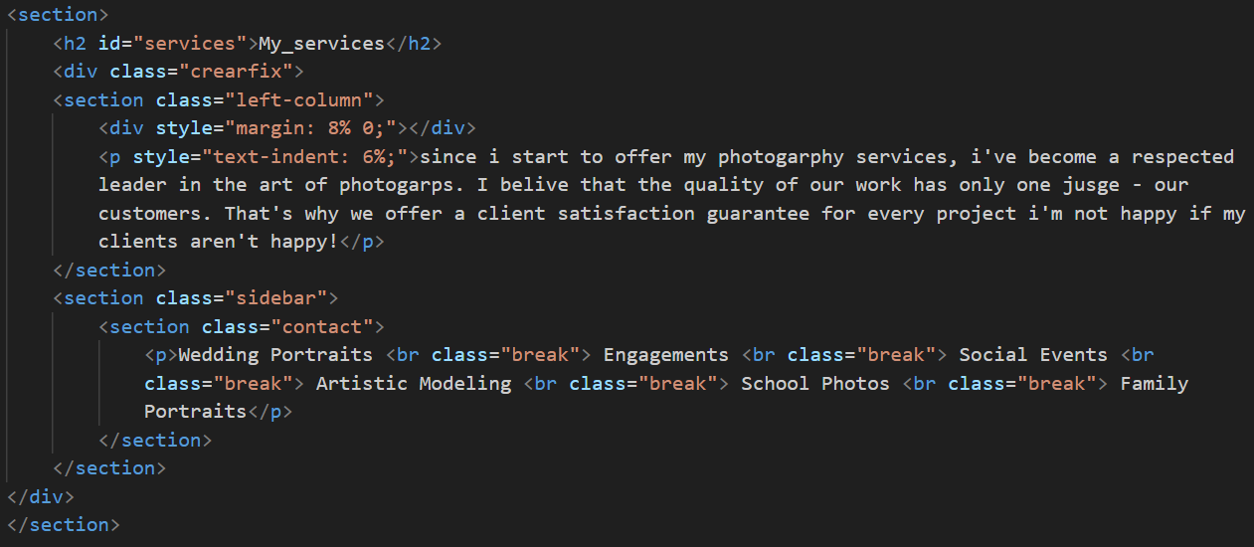

Figure 20 : HTML Code in Services Section

This is showing the site looks so for without CSS the services section:

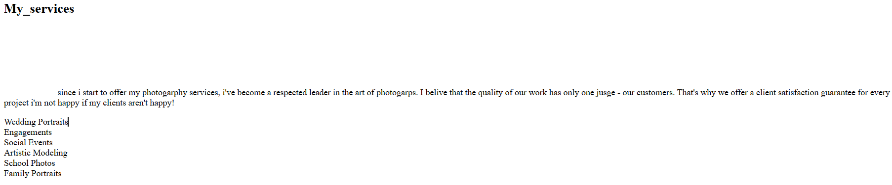

Figure 21 : Services Section Output without CSS

So let’s add some CSS to increase the font icon font size and card height and add some extra color when a user hovers over a card.

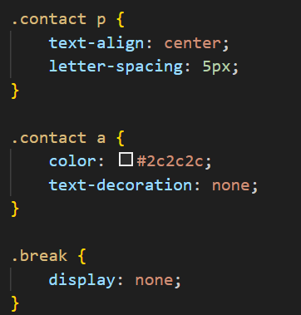

Figure 22 : CSS Code in Services section

I am used the same CSS code for about section and services section.

This is showing the site looks so for with CSS the Services section:

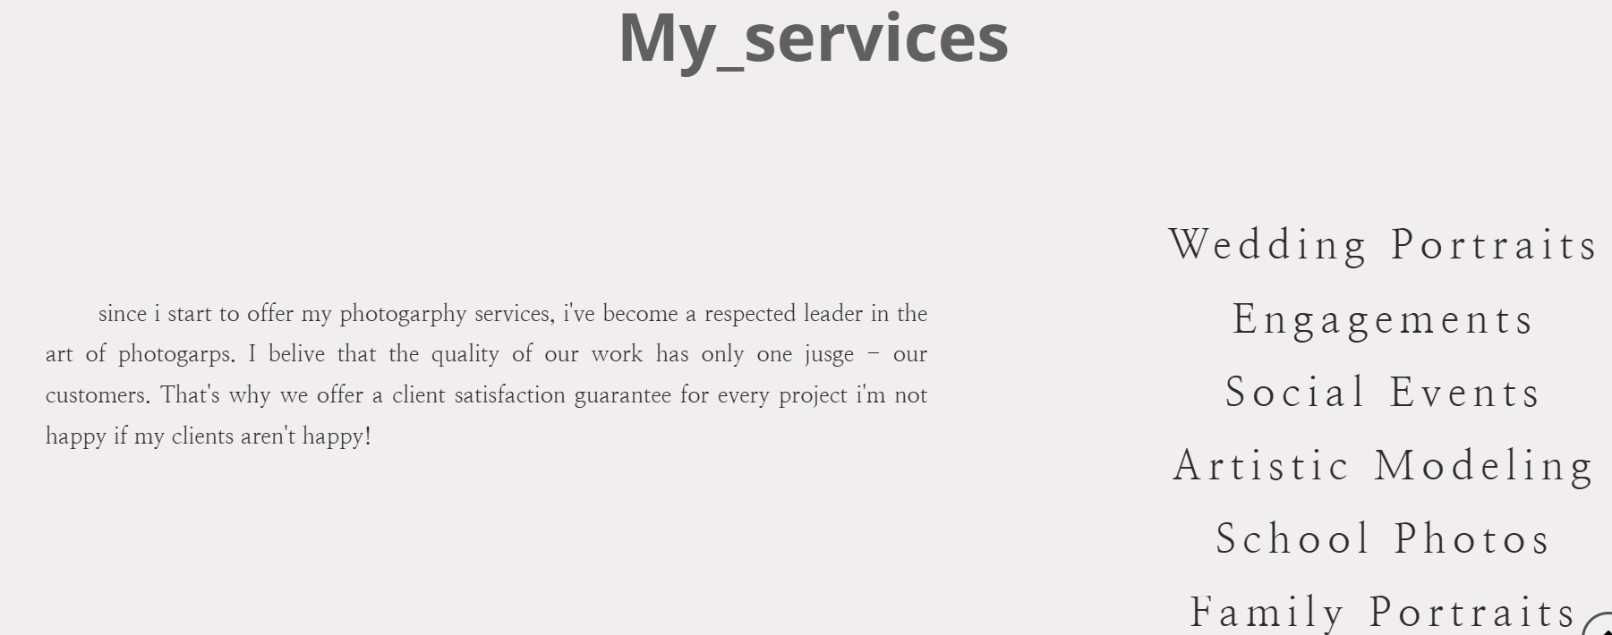

Figure 23 : Services section Output with HTML and CSS

## Content Section

I should include My contact information in this section so that visitors can contact you if they want to hire me. This section, I can use the **iframe,** **form, table, tr, td, input, textarea and button** tag. Let’s add the code for this section and describe it below.

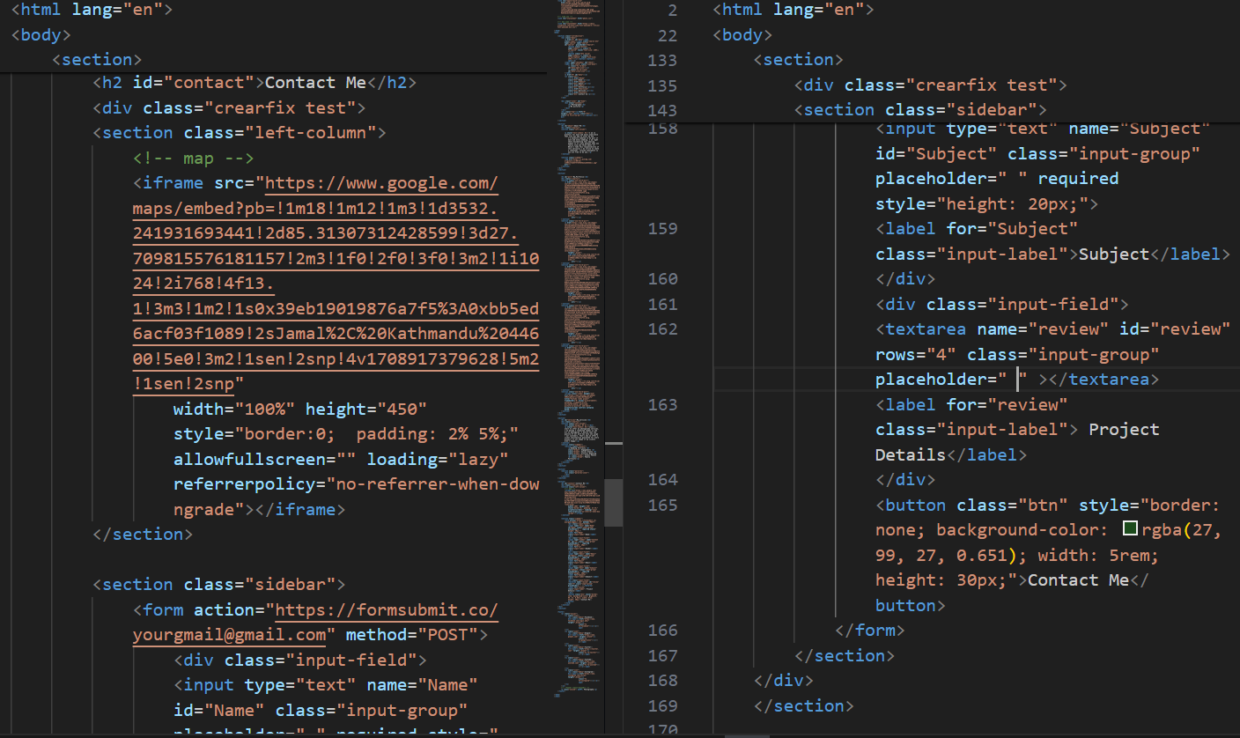

Figure 24 : HTML Code in Content section

This is showing the site looks so for without CSS the content section:

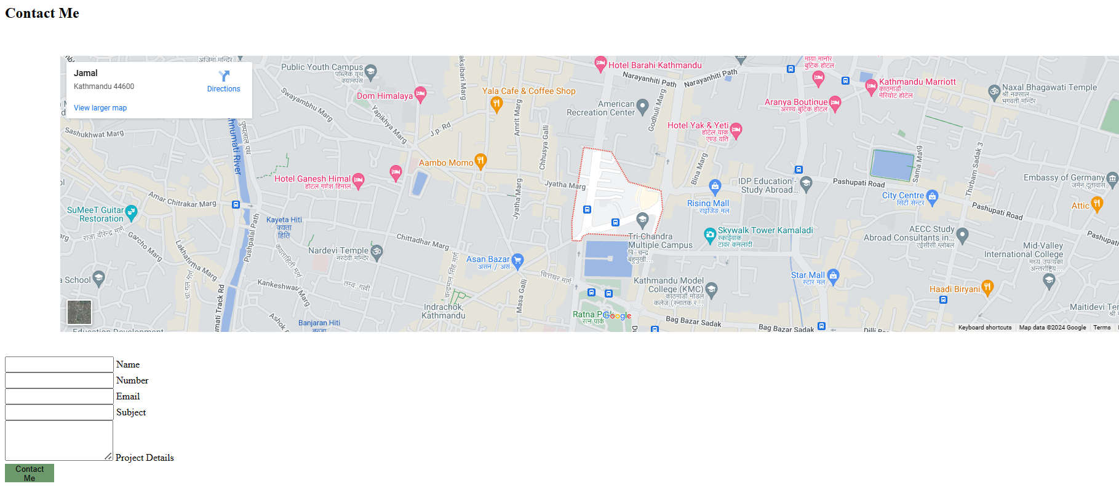

Figure 25 : Content Section Output without CSS

So let’s add some CSS to increase the add some extra color when a user hovers over a card.

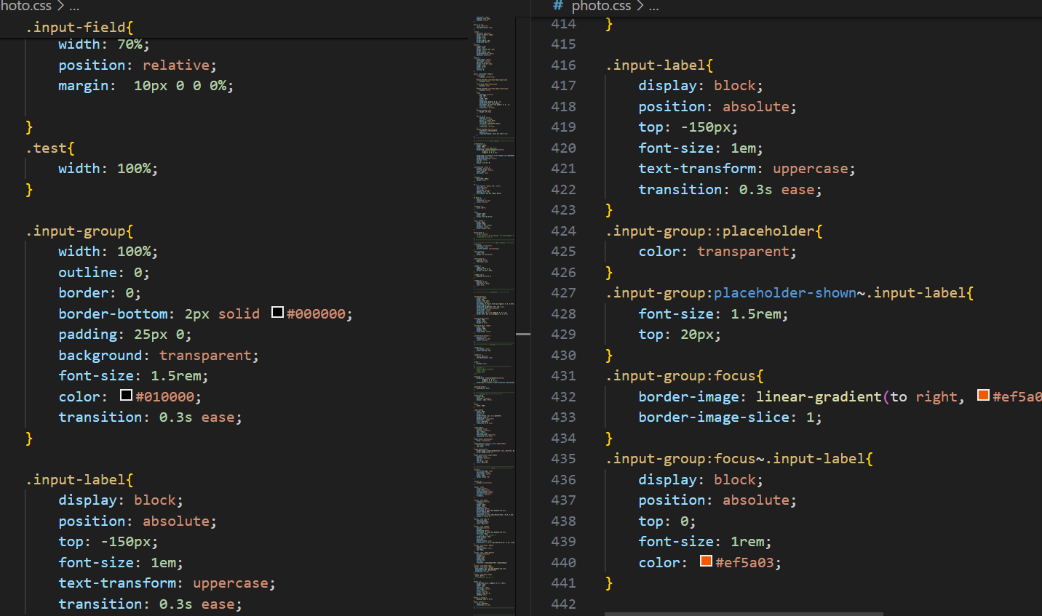

Figure 26 : CSS in Content Section

This is showing the site looks so for with CSS the content section:

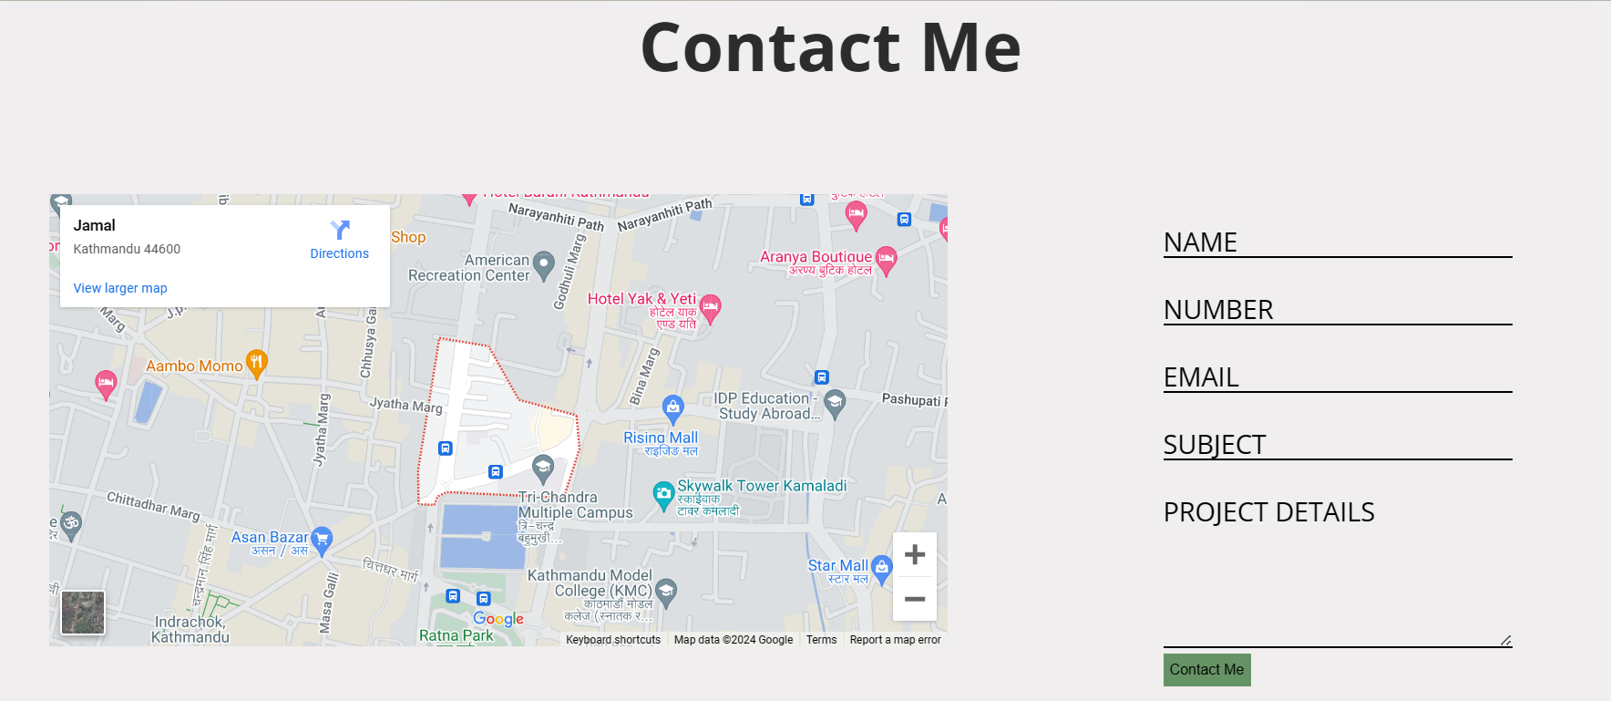

Figure 27 : Content Section Output with HTML and CSS

## Footer

Now I have come to the last section of this post, which is the footer section . I have already added a link to the font awesome CDN in the index.html file/

In the footer, I will add link to our social media through awesome icons.

So, let’s to the footer HTML code:

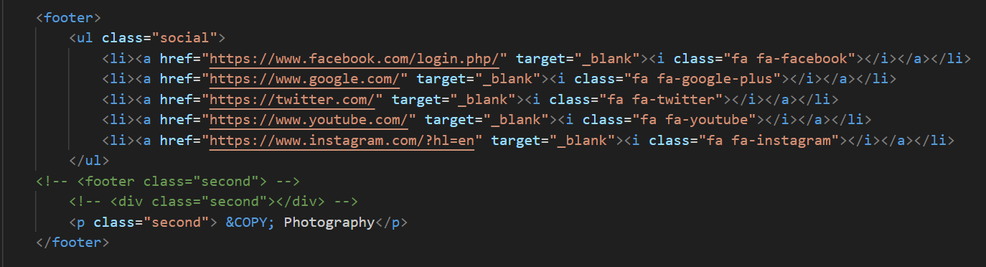

Figure 28 : HTML Code in Footer

This is showing the site looks so for without CSS the footer:



Figure 29 : Footer Output without CSS

The icons are now displayed in the center with a **hover** effect I can used.

So, let’s add some styling to the footer with this code:

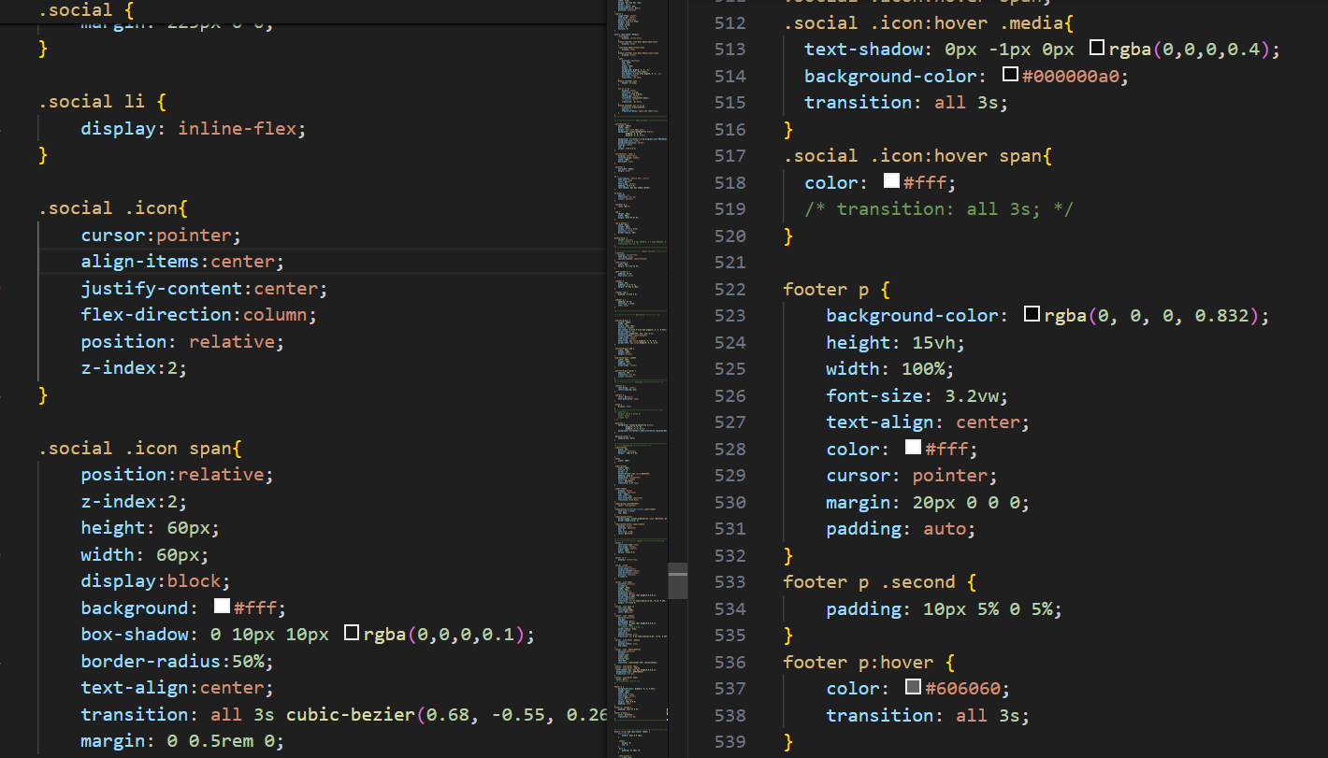

Figure 30 : Footer Code in CSS

This is showing the site looks so for with CSS the About section:



Figure 31 : Footer Output with HTML and CSS

## Final Touches

In order to add some spacing between all the sections, let’s add some more styling:

Now I am done making my complete photography website.

You can find the full source code of this project _____________ .

# **Conclusion :**

This is how I can create a complete responsive Photography website using HTML and CSS.

In this blog post I saw some of the benefits of creating a photography website for web developer and designers. I have divided the whole website into different section and discussed each one individually as I built it.

# **Reference :**

1. *HTML introduction*. Introduction to HTML. (n.d.). https://www.w3schools.com/html/html_intro.asp
2. CSS introduction. (n.d.). https://www.w3schools.com/css/css_intro.asp
3. *HTML & CSS projects with source code*. CodePel. (n.d.). https://www.codepel.com/category/html-css/
4. Mikke. (2023, December 4). *32 HTML and CSS projects for beginners (with source code)*. Mikke Goes Coding. https://mikkegoes.com/html-and-css-projects/